**SIR APOLLO**

**END OF TERM III EXAMINATION 2023**

**P.5 INTEGRATED SCIENCE**

***Time Allowed: 2hours 15 Minutes***

**Pupil’s Name: ……………………………………..……………………**

**Class: ……………………………..………………………………………**

**School Name: ………………………………………………………….**

|  |  |  |
| --- | --- | --- |
| **FOR EXAMINERS’**  USE ONLY | | |
| **Qn. No.** | **MARKS** | **EXR’S**  **No.** |
| **1 - 10** |  |  |
| **11 – 20** |  |  |
| **21 – 30** |  |  |
| **31 – 40** |  |  |
| **41 – 43** |  |  |
| **44 – 46** |  |  |
| **47 – 49** |  |  |
| **50 - 52** |  |  |
| **53 - 55** |  |  |
| **TOTAL** |  |  |

***Turn* Over**

**Read the following instructions carefully:**

1. This paper has two sections: **A** and **B**
2. Section **A** has 40 questions (40 marks)
3. Section **B** has 15 questions (50 marks)
4. Answer all questions. All the working for both sections A and B must be shown in the spaces provided.
5. All working must be done using a blue or black ball point pen or ink. Any work done in pencil will NOT be marked except drawings and diagram.
6. Unnecessary changes in your work and handwriting that cannot be easily read may lead to loss of marks.
7. Do not fill anything in the table indicated

**“For examiners’ use only”** and the boxes inside the question paper.

**SECTION A (40 MARKS)**

1. What is matter?

____________________________________________________________________________

1. How do animals depend on plants?

_______________________________________________________________________________

1. Identify one way mushrooms are useful to man.

_______________________________________________________________________________

1. Name the last stage in a village food path.

_______________________________________________________________________________

1. Why does a black piece of cloth receive more heat than a white piece of cloth from the Sun?

_______________________________________________________________________________

1. In which part of the digestive system of man does absorption of water take place?

_______________________________________________________________________________

1. Mention one disease spread by a housefly.

_______________________________________________________________________________

1. How does a dog protect itself against enemies?

_______________________________________________________________________________

1. Give one example of a cereal crop.

_______________________________________________________________________________

1. Identify one cause of soil erosion.

_______________________________________________________________________________

1. 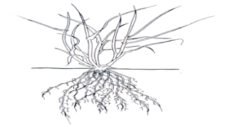Name the type of root system below.

___________________________________________________________

1. How is a measuring cylinder useful to a P.5 pupil in the Science Lab.?

_______________________________________________________________________________

1. Identify one factor a farmer should consider before setting a bee hive.

_______________________________________________________________________________

1. Write PHC in full.

_______________________________________________________________________________

1. Give one reason why farmers should keep farm records.

_______________________________________________________________________________

1. Name one bird that pollinates farmers’ crops.

_______________________________________________________________________________

1. State one way in which food is useful in our body.

_______________________________________________________________________________

1. What process enables plant roots to absorb water from the soil?

_______________________________________________________________________________

1. How is a vacuum flask an important device in a home?

_______________________________________________________________________________

1. Apart from painting, give one other way metals can be protected against rusting.

_______________________________________________________________________________

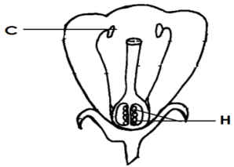 **The diagram below shows different parts of a flower.**

21. Name part labeled C.

________________________________________

22. What will part marked H develop into?

________________________________________

23. How are feelers (anteamnea) useful to an insect.

_______________________________________________________________________________

24. Give one way of preventing children against mosquito bites.

________________________________________________________________________________

25. Why is a fire extinguisher useful in a school?

_______________________________________________________________________________

26. Apart from egg eating, mention one other bad habit in poultry.

_____________________________________________________________________________

27. How are prop roots useful to a plant?

________________________________________________________________________________

28. State one reason why electric wires are loosely fixed between poles.

_______________________________________________________________________________

29. What name is given to the small stones found in the gizzard of a bird?

______________________________________________________________________________

30. Apart from mushrooms, give one other example of fungi.

______________________________________________________________________________

31. Which component of soil is used by green plants to make starch?

_______________________________________________________________________________

32. Identify one type of manure.

________________________________________________________________________________

33. Kakobogo stepped on ice and discovered that it was cold. Name the sense body organ that

enabled him to tell that it was cold.

________________________________________________________________________________

34. Why does a piece of paper float on water?

________________________________________________________________________________

35. Name one process by which matter changes state from liquids to gases.

________________________________________________________________________________

36. Nakibuuka fried sauce with onion spices and Dorothy could smell them in the next room. What

process enabled the smell to reach Dorothy in the next room?

________________________________________________________________________________

37. name the second stage in the life cycle of a cockroach.

________________________________________________________________________________

38. How do tape worms find their way into the human body?

________________________________________________________________________________

39. Change 50**o**c to **o**F.

40. State one way a farmer may keep soil fertile.

____________________________________________________________________________

**SECTION B**

41.a) What is a apiculture?

________________________________________________________________________________

b) State one cause of swarming in bees.

________________________________________________________________________________

c) How are bees useful to:

i) flowers ______________________________________________________________________

ii) people ______________________________________________________________________

42.a) Give one reason why movement is important to animals.

________________________________________________________________________________

b) Which body organs perform the following functions in man:

i) removing sweat _______________________________________________________________

ii) removing impurities from blood __________________________________________________

c) Name one way a P.5 child can keep his/her body organs in a good (healthy) condition.

________________________________________________________________________________

43.a) Mention two ways in which bacteria can be useful to man.

i) ______________________________________________________________________________

ii) ______________________________________________________________________________

b) Suggest any two dangers of bacterial to man.

i) ______________________________________________________________________________

ii) ______________________________________________________________________________

44.a) Name any two types of thermometers.

i) ______________________________________ ii) __________________________________

b) Other than mercury, name another liquid used in thermometers.

________________________________________________________________________________

c) Give one advantage of using mercury in thermometers.

________________________________________________________________________________

45. **The diagram below shows an experiment carried out by Gabula Charles of P.5.**

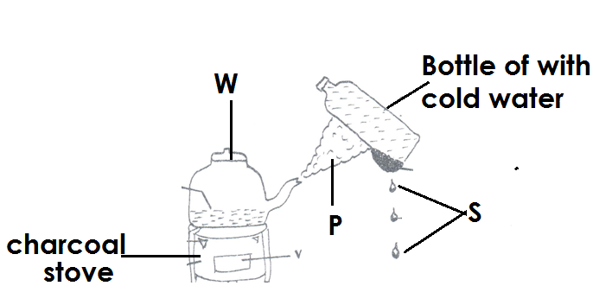

1. What name is given to substance P?

____________________________________________________________________________

b) By what process is substance S formed?

________________________________________________________________________________

c) Identify one process in the environment similar to that shown.

________________________________________________________________________________

d) What material is suitable for making part W?

________________________________________________________________________________

46.a) Air is a mixture of gases. Mention two components of air.

i) _______________________________________ ii) __________________________________

b) What name is given to moving air?

________________________________________________________________________________

c) Give one danger of moving air to man.

________________________________________________________________________________

d) What element of air is used by green plants to make starch?

________________________________________________________________________________

47. **Match items in A to those in B properly.**

**A** **B**

Lack of vitamin A Kwashiorkor

Lack of Iron. Marasmus

Lack of proteins Night blindness

Lack of carbohydrates Anaemia

a) Lack of vitamin A _________________________________________________________

b) Lack of iron _______________________________________________________________

c) Lack of proteins ___________________________________________________________

d) Lack of carbohydrates ________________________________________________________

48. **The diagram below shows a stem tuber.**

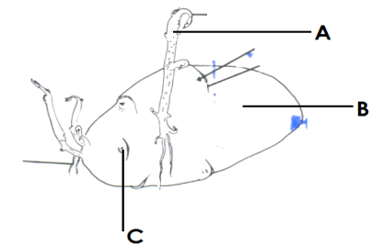

a) Name parts labeled A and B

i) A __________________________________ ii) B ________________________________

b) How are irish potatoes propagated?

_______________________________________________________________________________

c) What food value is directly got from eating irish potatoes?

______________________________________________________________________________

49.a) What is heat?

________________________________________________________________________________

________________________________________________________________________________

b) Name one natural source of heat.

______________________________________________________________________________

c) By what process does heat travel through:

i) gases _____________________________________________________________________

ii) solids ____________________________________________________________________

50.a) Name the type of immunity got after recovering from a disease.

_______________________________________________________________________________

b) Name one disease whose vaccine is given at birth.

_______________________________________________________________________________

c) Which immunisable disease affects the skeleton?

_______________________________________________________________________________

d) Identify the body which organizes and carries out immunization programmes in Uganda?

______________________________________________________________________________

51.a) What is poultry?

_______________________________________________________________________________

b) Give one type of chicken.

_______________________________________________________________________________

c) Write down two reasons why people keep domestic birds.

i) _____________________________________________________________________________

ii) ____________________________________________________________________________

52.a) Give one example of each of the following types of changes.

i) physical change ________________________________________________________________

ii) biological change _________________________________________________________________

iii) chemical change _________________________________________________________________

b) Write one characteristic of a chemical change.

________________________________________________________________________________

53.a) What is germination?

______________________________________________________________________________

1. Identify the type of germination shown below:

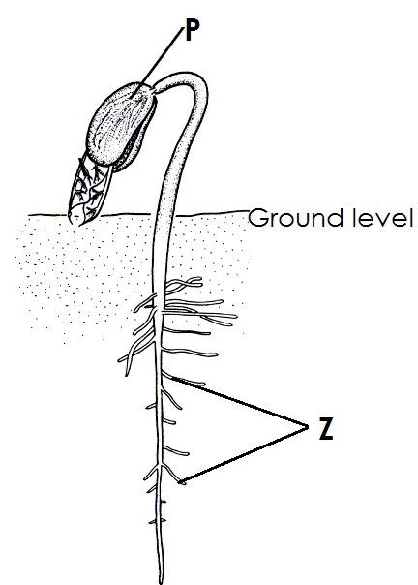______________________________________________________________________

1. Name part labeled P.

_________________________________________________________________

1. Give the use of part Z to a germinating seed.

_________________________________________________________________________

54.a) What are root crops.

________________________________________________________________________________

b) Mention any two examples of root crop.

i) __________________________________ ii) ____________________________________

c) Give one reason why, root crops are sprayed.

________________________________________________________________________________

55. James mixed the following sugar, salt and water and stirred.

a) What do you think happened to the sugar and salt after some time?

________________________________________________________________________________

b) What did the following act as:

i) water ________________________________________________________________________

ii) sugar and salt ________________________________________________________________

c) Mention one method of separating mixtures.

______________________________________________________________________________

**END**